16.30: For a string fixed at both ends, Equation 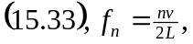 is useful. It is important to remember the second overtone is the third harmonic. Solving for v,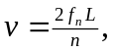 and inserting the data, 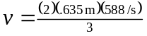, and 